NEHA SHANTAGIRI



We express our sincere thanks to our institution Sri

Chaitanya Techno School, for providing the necessary

facilities which were required for the completion of this

project.

We would like to express a deep sense of thanks and

gratitude to our teacher and guide, Mrs. Vishwaja, for

guiding and correcting us through the course of building

the project. She always expressed a keen interest in our

work. Her constructive advice and constant motivation has

been our inspiration for the successful completion of the

project.

We also thank our parents and friends for their help,

support and constant motivation.



1. About The Project

2. Files, Libraries, and Databases

3. Source Code

4. Screenshots

5. Bibliography



DecixBMS is a simple bank management system written in Python

and MySQL. Our aim was to develop software catering to the

financial applications of a customer in a banking environment.

It provides various ways to perform banking tasks, and hence

DecixBMS was created. DecixBMS, undertaken as a project is based

on relevant technologies. The main aim of this project is to develop

software for the management of a bank.

This project has been developed to carry out processes easily and

quickly, which is not possible with the manual system, which was

surpassed by this software.

This project has been developed using Python 3.7.5 and MySQL

5.1, on Windows 10 release 19041.1, and is tested to be compatible

with the same.

We have also bundled an installer script written in Python to

automate the creation of the required database and tables, and

insert the necessary values in the tables for the program to work.



bms.py

pymysql

os

installer.py

bms (MySQL)

pymysql

os

menu

accounts

MySQL Configuration

menu

sno

integer

actions

varchar(40)

accounts

sno

integer

AccName

AccType

amount

varchar(40)

char(1)

integer

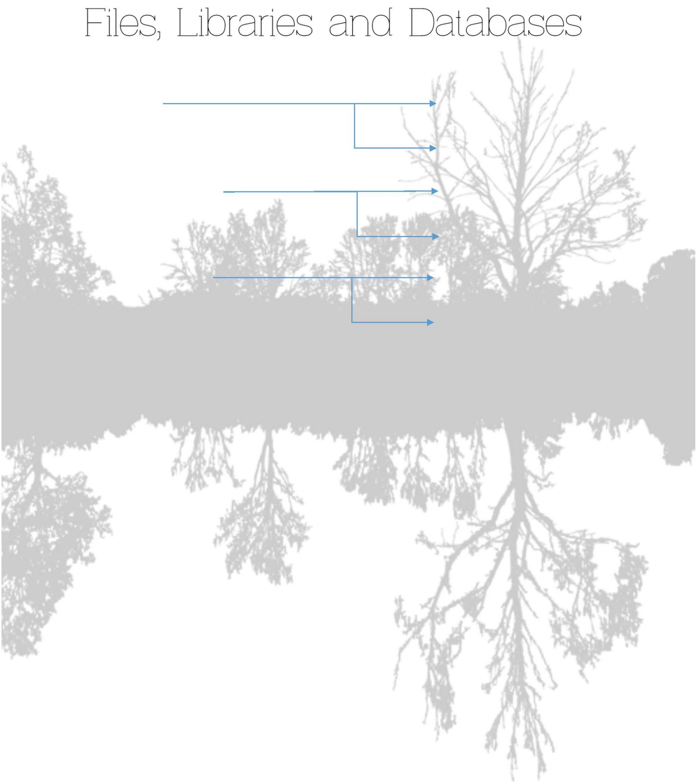

- bms.py

import pymysql as p

import os

def intro():

clrscr()

print("\t\t+------------------------------+")

print("\t\t| Bank Management System |")

print("\t\t+------------------------------+")

print("\t\t| The tool you can bank upon! |")

print("\t\t+------------------------------+")

input()

def NewAccount():

sno = input('Enter the new account number :')

name= input('Enter the new account name :')

Type= input('Enter account type [C/S]

amt = input('Enter initial amount

c = p.connect

:')

:')

(host='localhost',user='root',password='Gaganmalvi@123',database='bms')

a = c.cursor()

q1 = 'insert into accounts

values('+str(sno)+','+str(name)+','+str(Type)+','+str(amt)+');'

a.execute(q1)

c.commit()

print('New account created successfully, press any key to continue...')

def clrscr():

if os.name=="nt":

u = os.system("cls")

else:

u = os.system("clear")

def modifyAccount(num):

c = p.connect

(host='localhost',user='root',password='Gaganmalvi@123',database='bms')

a = c.cursor()

sno = input('Enter the account number

: ')



name = input('Enter the name of the account holder: ')

acctype = input('Enter type of account (C/S)

: ')

q1 = 'update accounts set AccName = '+str(name)+' where sno = '+str(sno)

q2 = 'update accounts set AccType = '+str(acctype)+' where sno = '+str(sno)

a.execute(q1)

a.execute(q2)

c.commit()

print('Account updated successfully. Press any key to continue.')

def deposit(num):

print('Deposit to Account Number: ',num)

amount = input ('Enter the amount to deposit:')

c = p.connect

(host='localhost',user='root',password='Gaganmalvi@123',database='bms')

a = c.cursor()

q1 = 'update accounts set amount=amount+'+str(amount)+' where sno='+str(num)+';'

a.execute(q1)

c.commit()

print('Deposited the required amount successfully. Press any key to continue.')

def withdraw(num):

print('Withdraw to Account Number: ',str(num))

amount = input ('Enter amount to withdraw: ')

c = p.connect

(host='localhost',user='root',password='Gaganmalvi@123',database='bms')

a = c.cursor()

q1 = 'update accounts set amount=amount-'+str(amount)+' where sno='+str(num)+';'

a.execute(q1)

c.commit()

print('Withdrew the required amount successfully, press any key to continue.')

def balanceEnquiry(num):

print('Balance (Account Number: '+str(num)+')')

c = p.connect

(host='localhost',user='root',password='Gaganmalvi@123',database='bms')

a = c.cursor()

q = 'select amount from accounts where sno='+str(num)+';'

a.execute(q)

d = a.fetchall()

print('==========================')

for i in d:

for j in i:

print ('Balance in INR:',j,end='\t')



print()

def deleteAccount(num):

x = input('DELETING ACCOUNT FOR S/N '+str(num)+'DO YOU WANT TO CONTINUE? CHANGES

ARE IRREVERSIBLE! (Y/N):')

if x == 'Y':

c = p.connect

(host='localhost',user='root',password='Gaganmalvi@123',database='bms')

a = c.cursor()

a.execute('delete from accounts where sno='+str(num)+';')

c.commit()

print('Deleted account successfully, press any key to continue')

else:

print('Wrong option, try again!')

def displayAll():

c = p.connect

(host='localhost',user='root',password='Gaganmalvi@123',database='bms')

a = c.cursor()

a.execute('select * from accounts;')

d = a.fetchall()

print ('List of All Account Holders')

print ('===========================')

print ('AccountNo\tAccountHolder\t\tType\t\tAmount')

print ('=========\t=============\t\t====\t\t======')

for i in d:

for j in i:

print (j,end='\t\t')

print()

ch=''

num=0

intro()

while ch != 8:

clrscr()

print('=====================')

print('Decix Bank Management')

print('=====================')

c = p.connect

(host='localhost',user='root',password='Gaganmalvi@123',database='bms')

a = c.cursor()



q = 'select * from menu'

a.execute(q)

d = a.fetchall()

print ('Option\tAction')

for i in d:

for j in i:

print (j,end='\t')

print()

print("Select Your Option (1-8) ")

ch = input()

if ch == '1':

clrscr()

NewAccount()

elif ch =='2':

clrscr()

num = int(input("Enter The account No. : "))

deposit(num)

elif ch == '3':

clrscr()

num = int(input("Enter The account No. : "))

withdraw(num)

elif ch == '4':

clrscr()

num = int(input("Enter The account No. : "))

balanceEnquiry(num)

elif ch == '5':

clrscr()

displayAll()

elif ch == '6':

clrscr()

num =int(input("Enter The account No. : "))

deleteAccount(num)

elif ch == '7':

clrscr()

modifyAccount(num)

elif ch == '8':

clrscr()

print("\t+-----------------------------+")

print("\t|Thank you for using DecixBMS!|")

print("\t+-----------------------------+")

break

else :



print("Invalid choice")

ch = input()

- installer.py

import os

import pymysql as p

'''

DecixBMS Installer

Change the password to your MySQL passwd

'''

c = p.connect(host = 'localhost', user = 'root', password = 'Gaganmalvi@123')

a = c.cursor()

def clrscr():

if os.name=="nt":

u = os.system("cls")

else:

u = os.system("clear")

def installDecix():

a.execute('create database bms;')

a.execute('use bms;')

a.execute('create table menu (sno integer,actions varchar(40));')

a.execute('create table accounts(sno integer, AccName varchar(20),

AccType char(1), amount integer);')

a.execute('insert into menu values(1,"New Account");')

a.execute('insert into menu values(2,"Deposit Money");')

a.execute('insert into menu values(3,"Withdrawal of Money");')

a.execute('insert into menu values(4,"Balance Enquiry");')

a.execute('insert into menu values(5,"Account Holders List");')

a.execute('insert into menu values(6,"Closure of Account");')

a.execute('insert into menu values(7,"Modify Account");')

a.execute('insert into menu values(8,"Exit BMS");')

c.commit()

print('Installed successfully!')

def uninstDecix():

a.execute('drop database bms;')

c.commit()

print('Uninstalled!')

def mainRun():

print('==================')



print('DecixBMS Installer')

print('==================')

print('1. Install DecixBMS')

print('2. Uninstall DecixBMS')

z = input('Choice:')

if z == '1':

installDecix()

elif z == '2':

uninstDecix()

else:

print('Wrong choice!')

mainRun()



Pre-installation

Post Installation

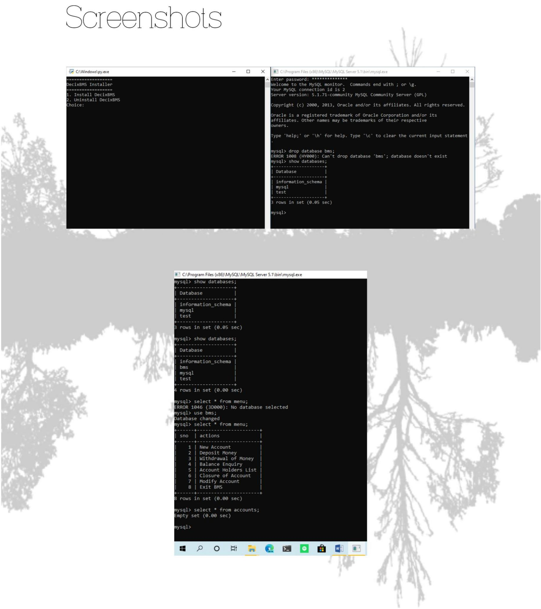

Splash

Menu

Create a New Account

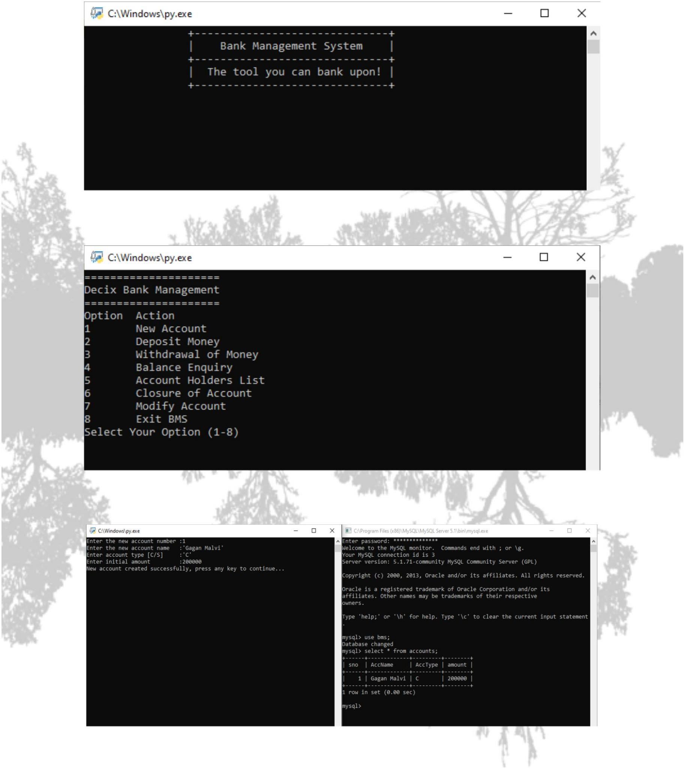

Deposit Money

Withdraw Money

List All Account Holders

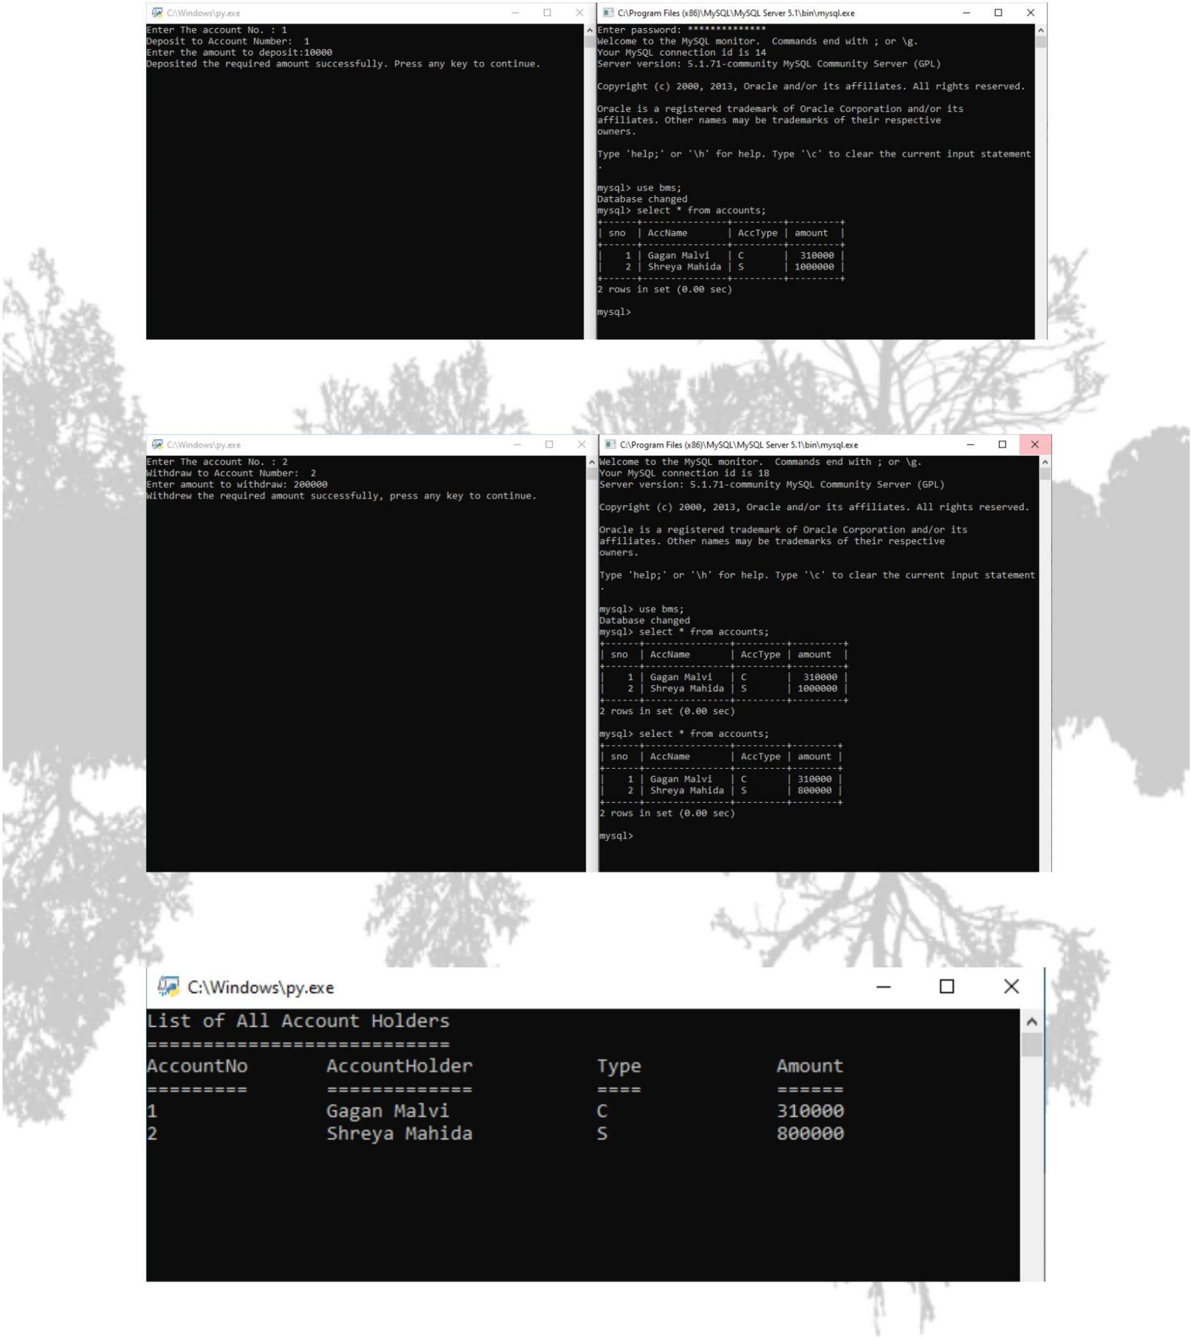

Balance Enquiry

Delete Account

Modify Account

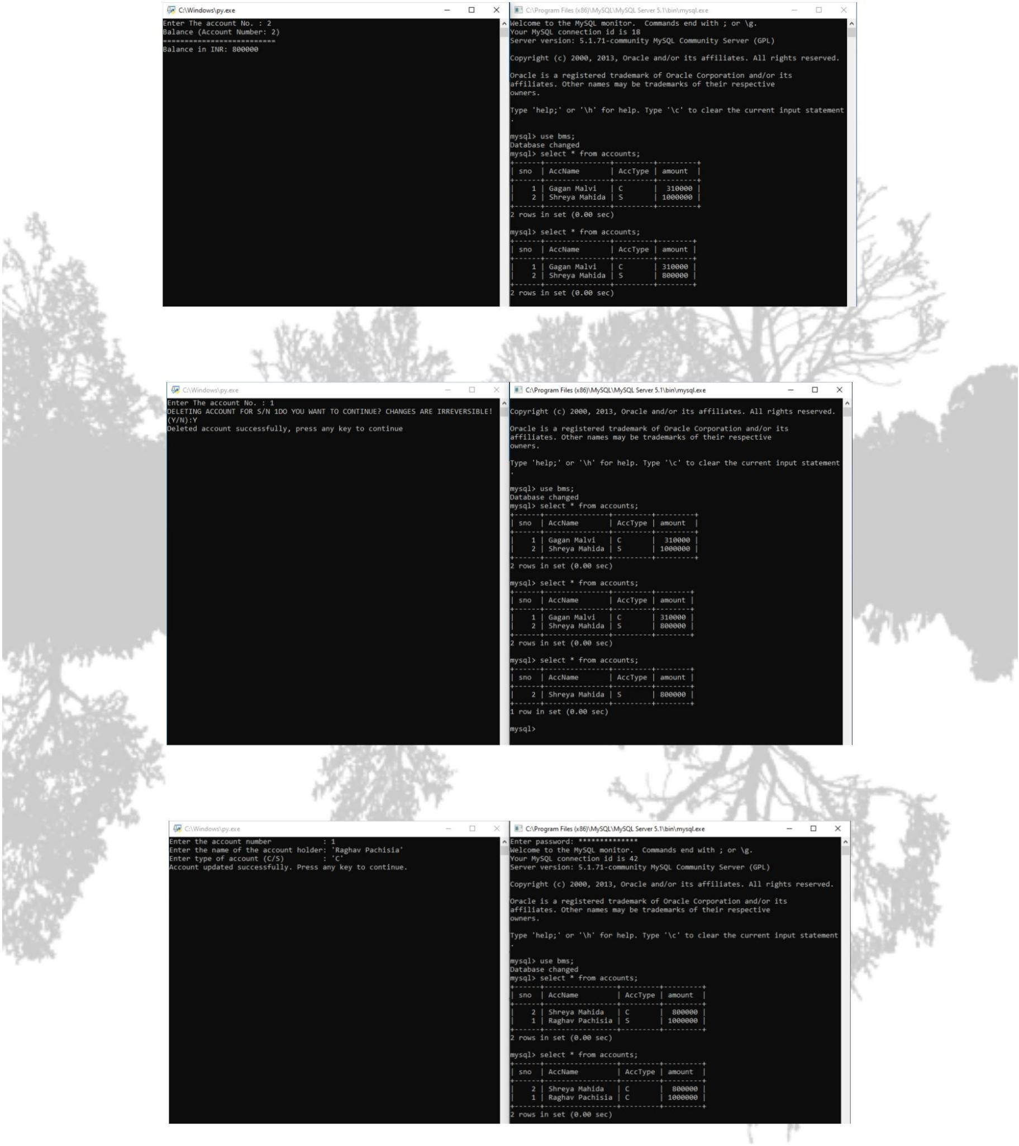

➔ Sources

[https://dev.mysql.com](https://dev.mysql.com/)

[https://wiki.python.org](https://wiki.python.org/)

[https://stackoverflow.com](https://stackoverflow.com/)

[https://pypi.org](https://pypi.org/)

[https://mirror.cse.iitk.ac.in](https://mirror.cse.iitk.ac.in/)

[https://guru99.com](https://guru99.com/)

➔ References

IP Manual

Python Wiki

Windows Community

